**Practical 1**

**Introduction and Contribution to Wikipedia.**

1. **Description about Wikipedia and its features:**

**Description:** Wikipedia is a free, open content online encyclopedia created through the collaborative effort of a community of users known as Wikipedians. Anyone registered on the site can create an article for publication; registration is not required to edit articles. The site’s name comes from wiki, a server program that enables anyone to edit Web site content through their Web browser. Jimmy Wales amd Larry Sanger co-founded Wikipedia as an offshoot of an earlier encyclopedia project, Nupedia, in January 2001. Originally, Wikipedia was created to provide content for Nupedia. However, as the wiki site became established it soon grew beyond the scope of the earlier project. As of January 2015, the website provided well over five million articles in English and more than that number in all other languages combined. At that same time, Alexa ranked Wikipedia as the seventh-most popular site on the Internet. Wikipedia was the only non-commercial site of the top ten.

**Features:**

* Create a page.
* Edit a page.
* Link between pages.
* Full page search.
* Hierarchical page display.
* A list of the most recently searched pages.
* Searching with tags.

1. **Creating account on Wikipedia:**

Step 1: Click on the “Create account” on the upper right corner.

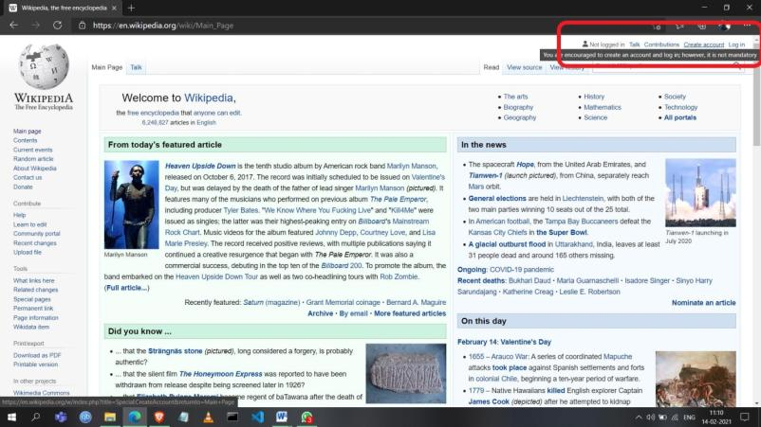

Step 2: Fill in the required details and click on the “Create account” button.

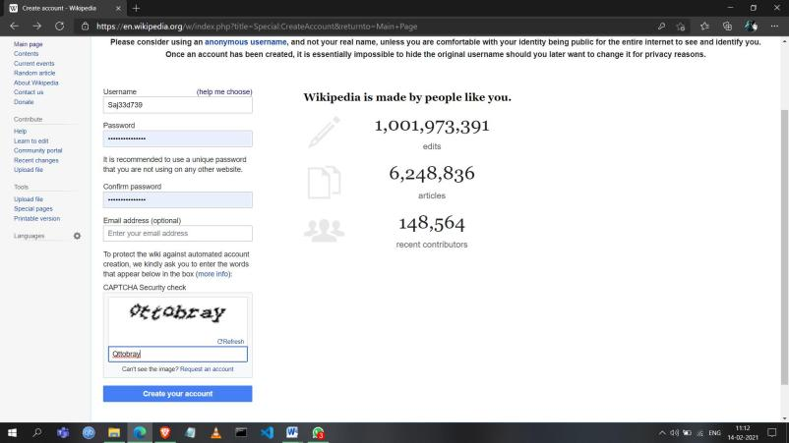

After clicking the button the account will be created.

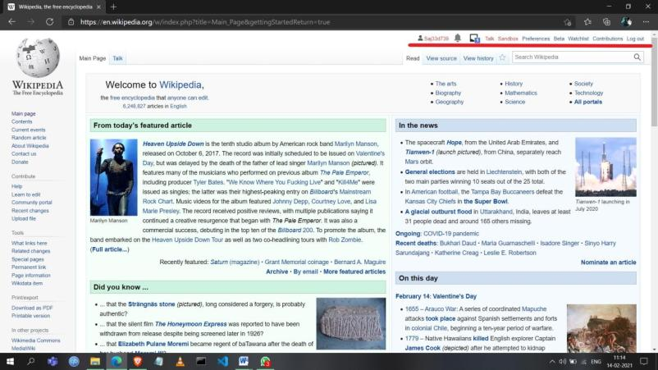

1. **Creating your page on Wikipedia:**

Step 1: Click on your username on the upper right corner.

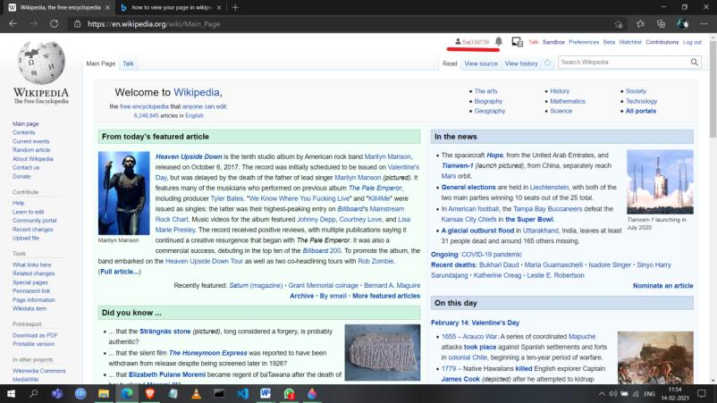

Step 2: Click on “create source” to start creating the page.

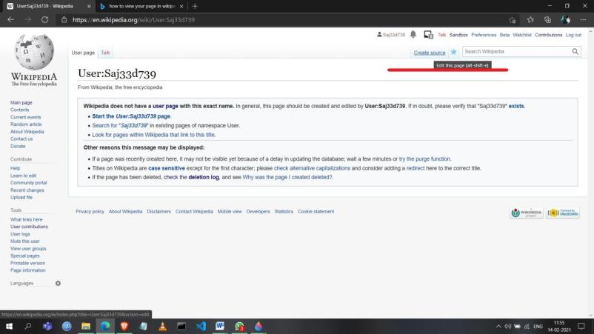

Step 3: Insert your data for the page you want to create in the given text window.

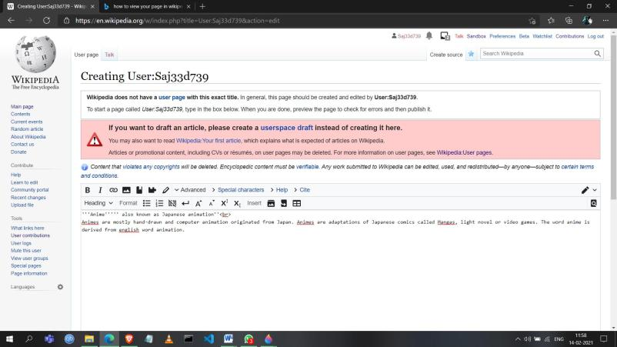

Step 4: Click on the “Show preview” button to see the preview of the page.

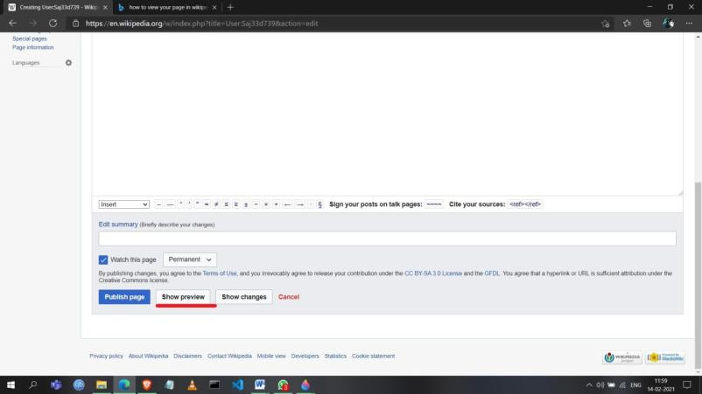

After clicking the button, page preview will be displayed.

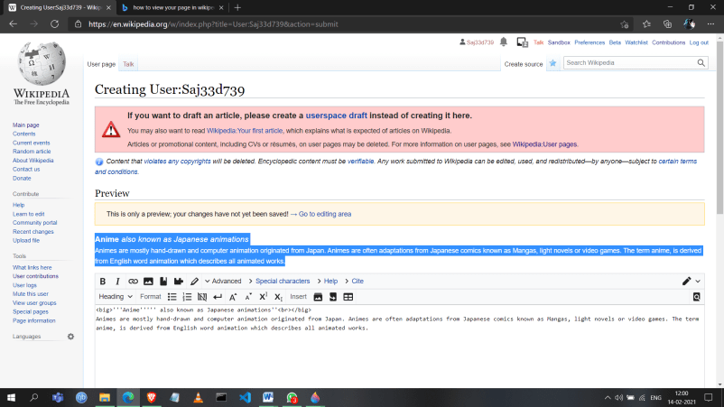

Step 5: Click on the “Publish page” button to publish or create the page.

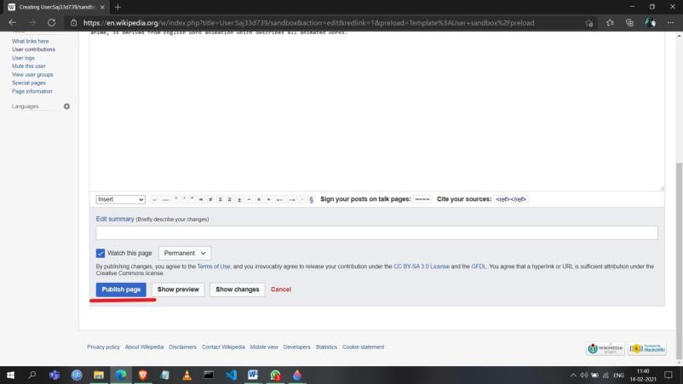

Your Wikipedia page will be created as shown below.

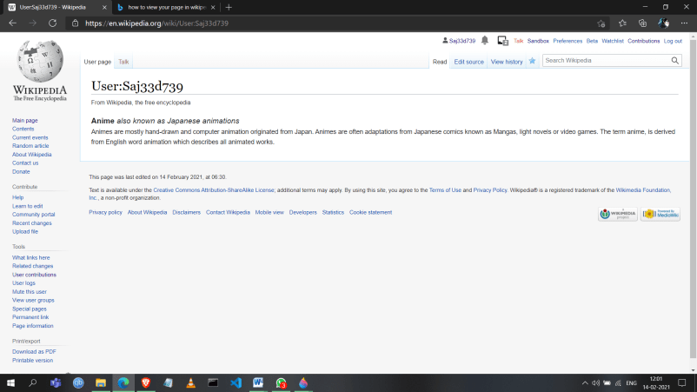

1. **Editing your page on Wikipedia:**

Step 1: Click on “Edit source”.

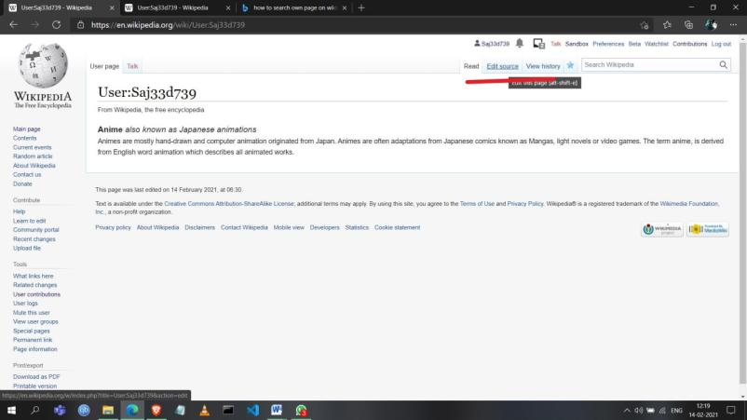

Step 2: Make the required changes and click on the “Publish changes” button to finish the edit.

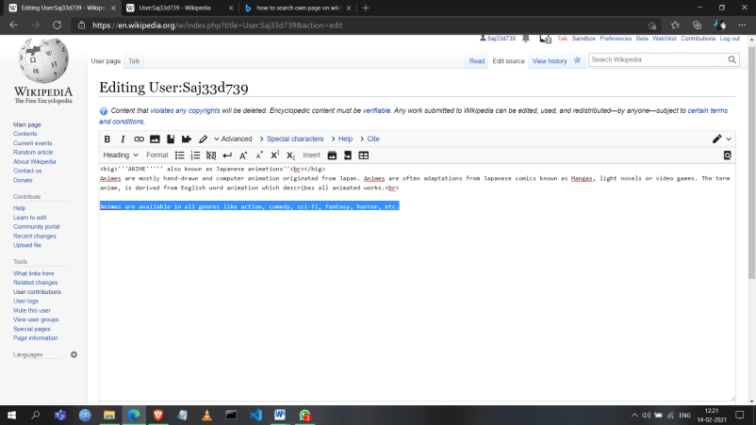

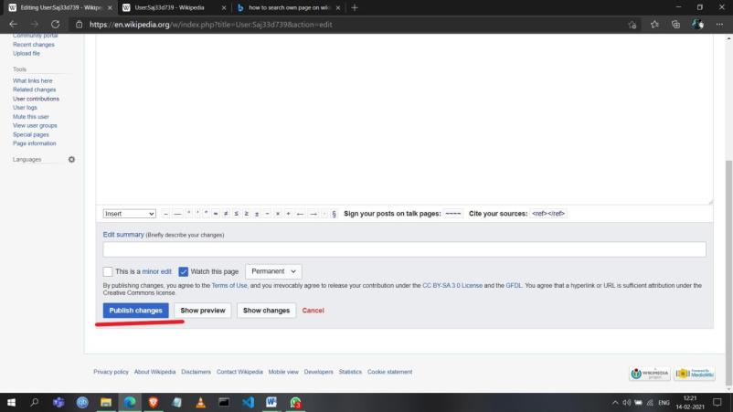

As we can see the changes has been made.

